Week6_Functional Component with Styling (scorecalculatorapp)
Objective:
Create a react app for Student Management Portal named scorecalculatorapp and create a function component named “CalculateScore” which will accept Name, School, Total and goal in order to calculate the average score of a student and display the same.

Phase 1: Setting Up Your Development Environment
Step 1: Install Node.js and npm
- Explanation: Node.js is a JavaScript runtime that lets you run JavaScript on your computer. npm is the package manager for Node.js, used to install and manage project dependencies like React.
- Action:
- Open a web browser and navigate to the official Node.js download page: https://nodejs.org/en/download/
Step 2: Install Visual Studio Code
- Explanation: Visual Studio Code (VS Code) is a free, powerful code editor that is highly recommended for React development.
- Action:
- Go to the official VS Code website: https://code.visualstudio.com/
- Download and run the installer for your operating system.
Step 3: Install create-react-app
- Open your command prompt (on Windows) or terminal (on macOS or Linux).
- Type the following command: npm install -g create-react-app
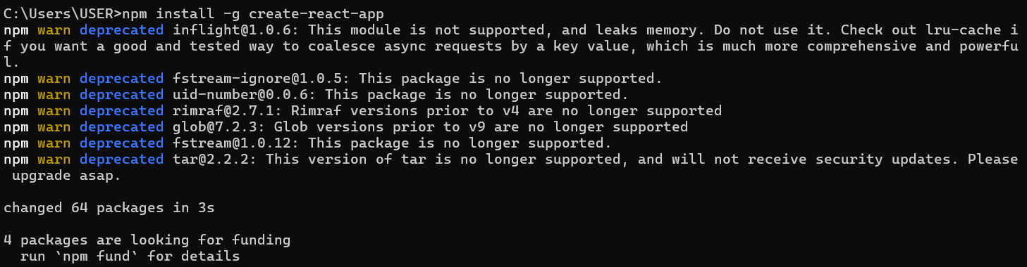

Phase 2: Creating and Running the React Application
Step 4: Create the React Application
- In your command prompt or terminal, navigate to the directory where you want to store your project (e.g., your Desktop or a development folder).
- Type the following command and press Enter. This may take a few minutes to complete.
create-react-app scorecalculatorapp

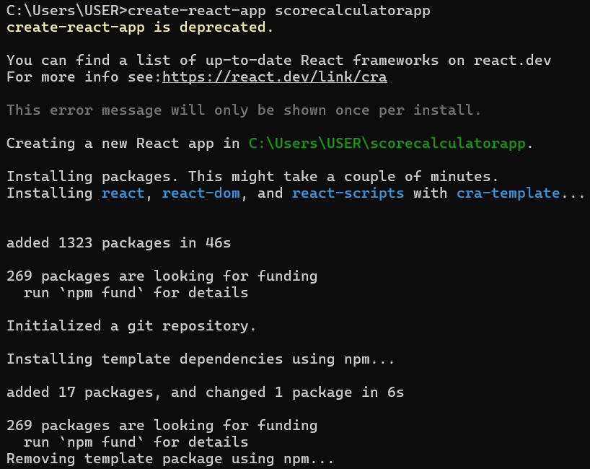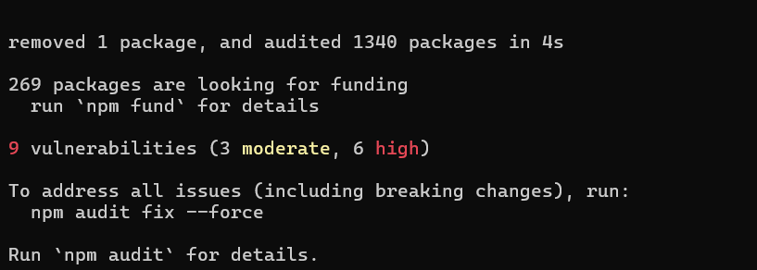
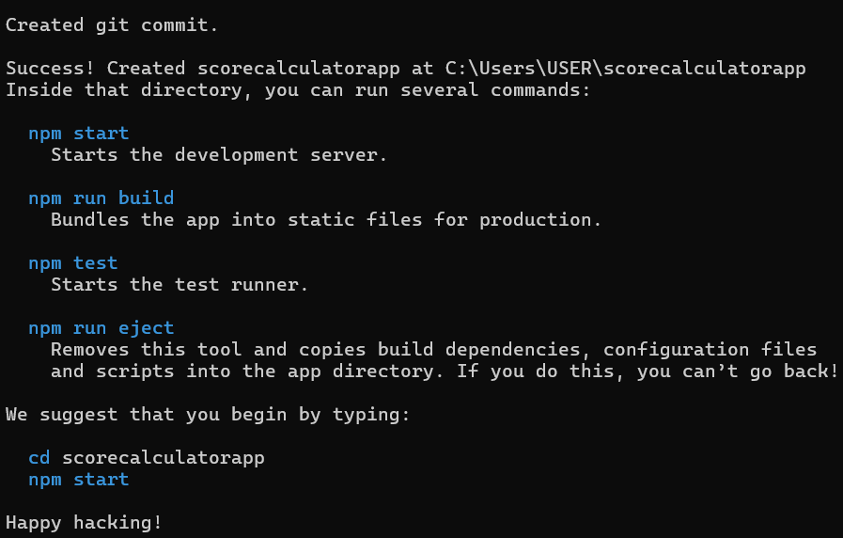
Step 5: Navigate into Your New Project Folder
- You must be inside the project folder to run commands related to this specific application.
- Once the command from Step 4 is finished, type the following command to move into the newly created directory:
cd scorecalculatorapp
Step 6: Open the Project in Visual Studio Code
- This command opens the entire project folder in VS Code, allowing you to easily browse and edit the project files.
- While in the myfirstreact folder in your command prompt or terminal,
- Type the command:
code .
Note: The . tells VS Code to open the current directory.
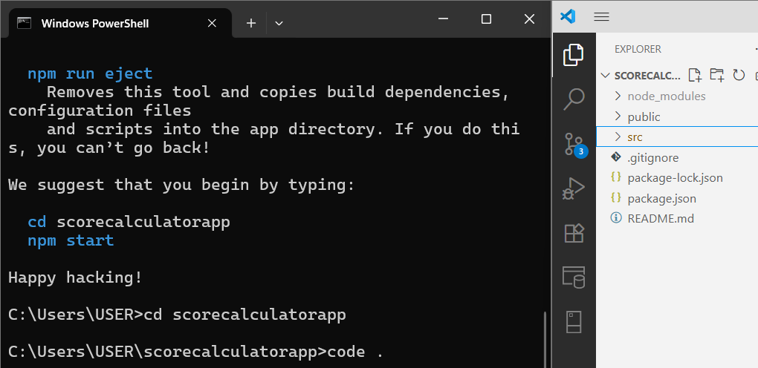
Step 7: Create Necessary Folders
- In VS Code, right-click the src folder and create a new folder named Components.
- Right-click the src folder again and create another new folder named Stylesheets.
Step 8: Create the CSS Stylesheet (mystyle.css)
- Inside the Stylesheets folder, create a new file named mystyle.css.
- Add the following code:
.formatstyle {
text-align: center;
font-size: large;
font-family: 'Arial';
}
.Name {
font-weight: 300;
color: blue;
}
.School {
color: crimson;
}
.Total {
color: darkmagenta;
}
.Score {
color: forestgreen;
}
Step 9: Create the Functional Component (CalculateScore.js)
- Inside the Components folder, create a new file named CalculateScore.js.
- Add the following code:
import React from 'react';
const CalculateScore = ({ Name, School, Total }) => {
// Calculate score out of 300 as per the example output
const score = (Total / 300) * 100;
return (
<div className="formatstyle">
<h2>Student Details:</h2>
<div className="Name">
<b>Name:</b> {Name}
</div>
<div className="School">
<b>School:</b> {School}
</div>
<div className="Total">
<b>Total:</b> {Total} Marks
</div>
<div className="Score">
<b>Score:</b> {score.toFixed(2)}%
</div>
</div>
);
};
export default CalculateScore;
Step 10: Edit the Main App.js File
- Open the App.js file from the src folder.
- Replace all of its content with this code:
import React from 'react';
import CalculateScore from './Components/CalculateScore';
import './Stylesheets/mystyle.css';
import './App.css';
function App() {
return (
<div className="App">
<CalculateScore
Name="Steeve"
School="DNV Public School"
Total={284}
/>
</div>
);
}
export default App;
Step 11: Run the Application
- Go back to your terminal (it should still be in the scorecalculatorapp folder).
- Run the start command:
npm start

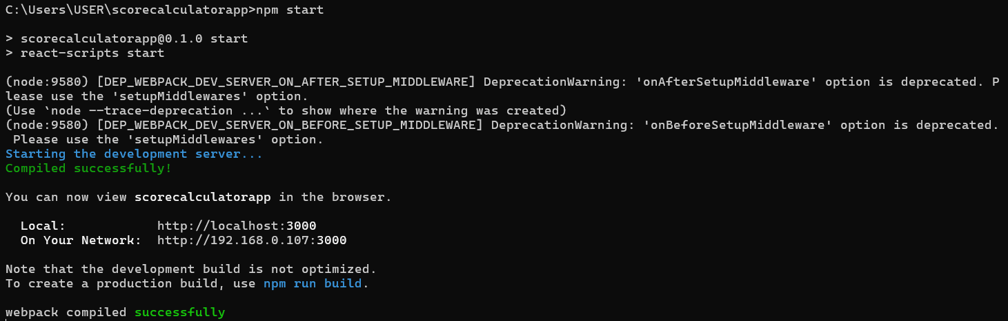
Step 12: View Your Application
- The development server hosts your application on a local port, typically 3000.
Local: http://localhost:3000
On Your Network: http://192.168.0.107:3000

Output:

